**MEDICAL INVENTORY MANAGEMENT**

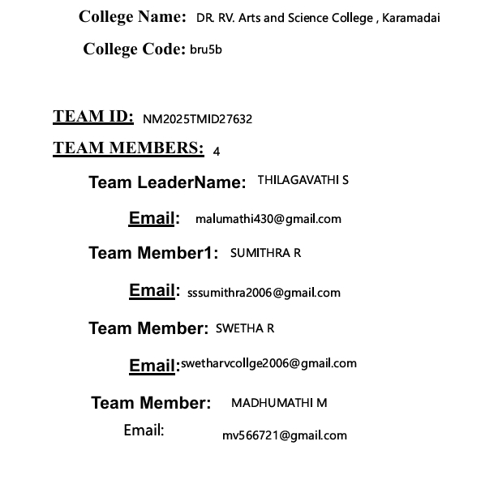**1.INTRODUCTION**

**1.1 Project Overview**

**Medical inventory management is the process of overseeing medical and pharmaceutical supplies, from procurement to disposal, to ensure healthcare professionals have the right items at the right time. It involves tracking inventory levels, managing expiration dates, controlling costs, and maintaining compliance with regulations. The goals are to prevent stockouts and waste, improve patient safety by ensuring access to necessary supplies, optimize resource allocation, and enhance overall operational efficiency in healthcare facilities.**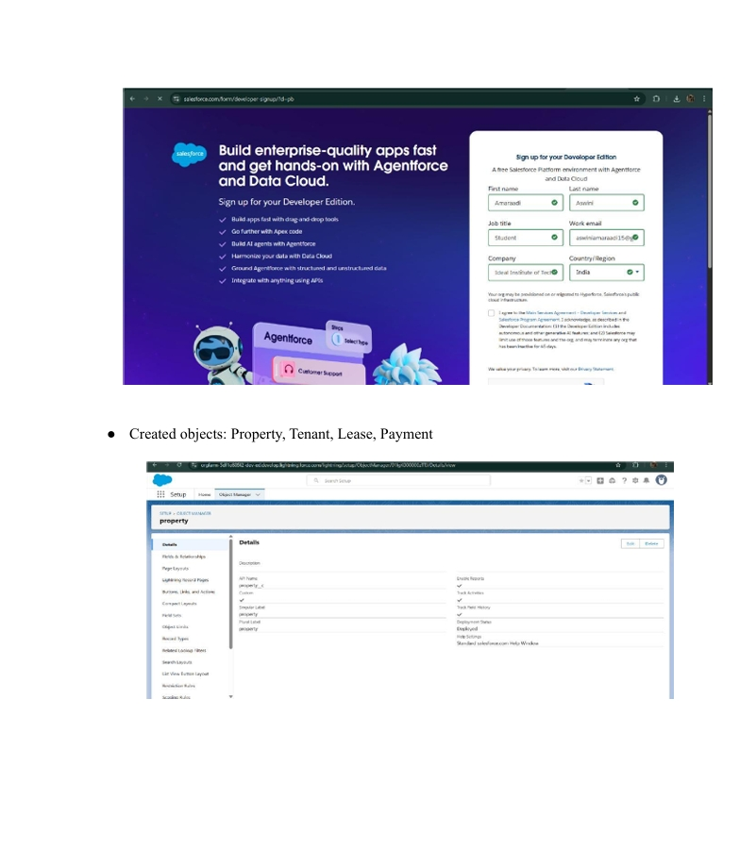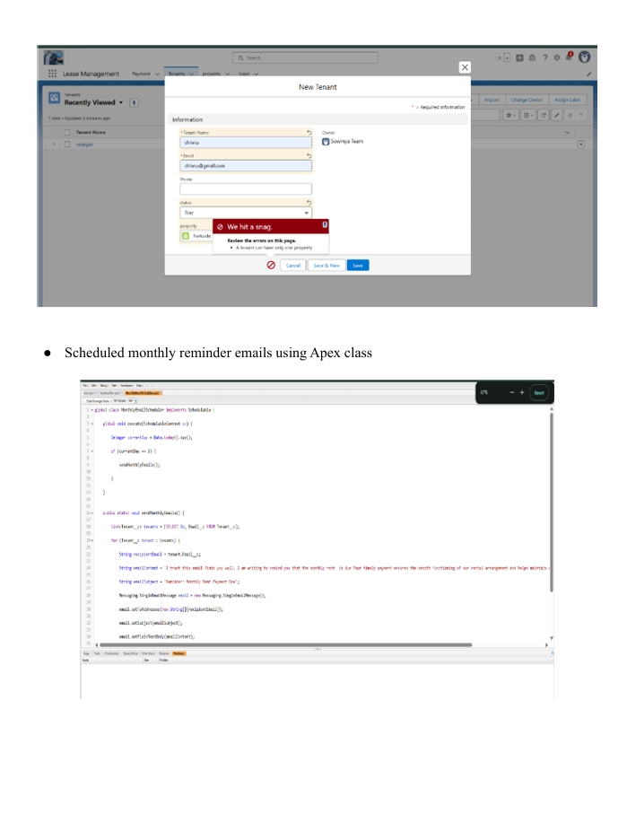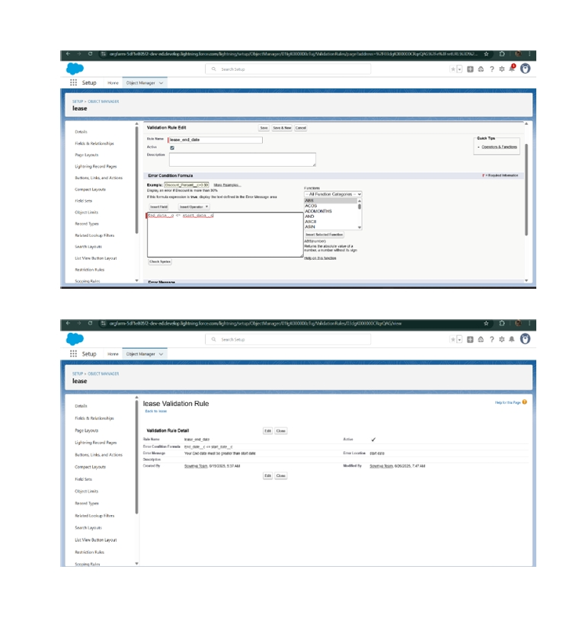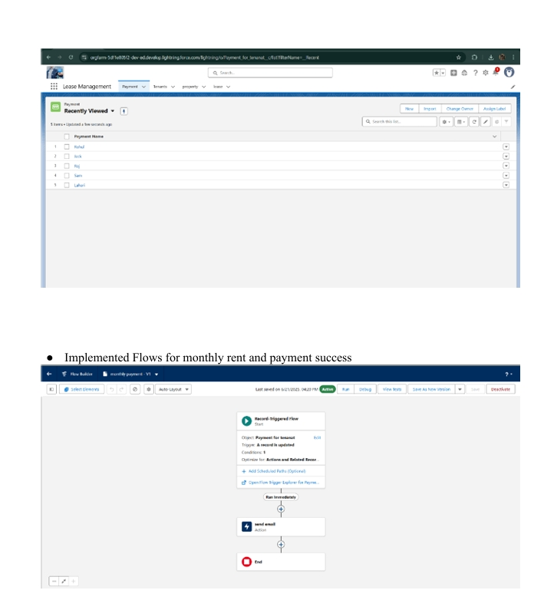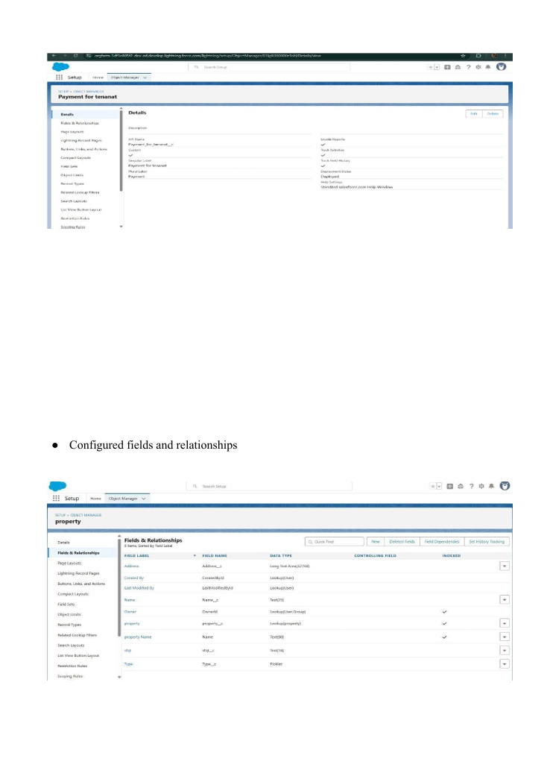

PURPOSE:

The purpose of medical inventory management is to ensure optimal stock levels of medical supplies and pharmaceuticals, which is crucial for patient safety, operational efficiency, and cost control within healthcare facilities. It achieves this by enabling healthcare providers to have the right items, in the right quantities, at the right time, minimizing waste from overstocking and preventing critical shortages that could disrupt patient care.

